**Image Operations**

**• Classification of Image Operations**

**-** Spatial domain methods

* Point Processing Tranformations

* Area/Mask Processing Tranformations

* Geometric Tranformations

* Frame Processing Transformations

- Frequency domain methods

**Point Processing Methods**

- The most primitive, yet essential, image processing operations.

- Intensity transformations that convert an old pixel into a new pixel based on some

predefined function.

- They operate on a pixel based solely on that pixel’s value.

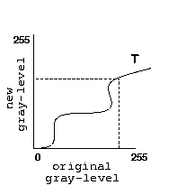- Used primarily for *contrast enhancement.*

**• Identity Transformation**

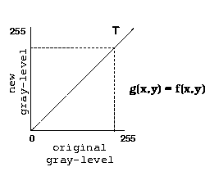

**• Negative Transformation**

O(r, c) = 255 − I (r, c)

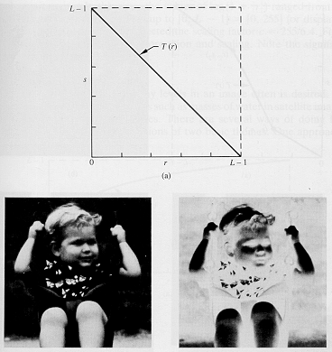

**• Contrast Stretching/Compression**

- Stretch gray-level ranges where we desire more information.

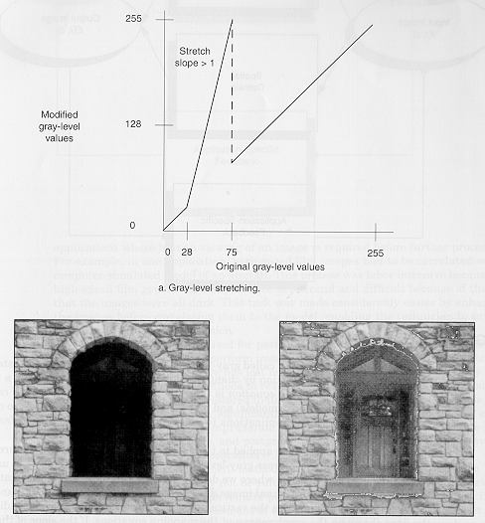

**• Intensity-Level Slicing**

- Highlight a specific range of gray-levels only.

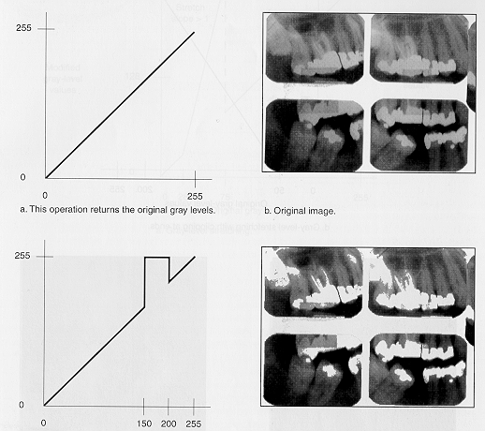(same as double-thresholding)

**• Non-linear Transformations**

- We may use any function, provided that is gives a one-to-one or many-to-one (i.e.,

single-valued) mapping.

Logarithmic

- Useful for enhancing details in the darker regions of the image at the expense of detail in the brighter regions.

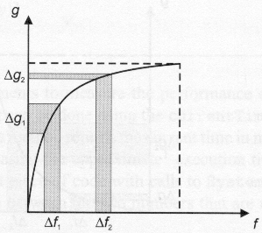

**Exponential**

- The effect is the reverse of that obtained with logarithmic mapping.

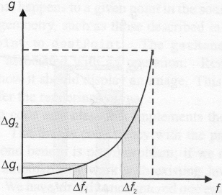

**• Thresholding**

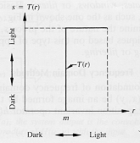

**• Histogram Equalization**

- Low contrast images are usually mostly dark, mostly light, or mostly gray.

- High contrast images have large regions of dark and large regions of white (e.g.,

someone inside a room, stading in front of a window on a sunny day).

- Good contrast images exhibit a wide range of pixel values (i.e., no single gray level

dominates the image).

- The histogram of an image (i.e., a plot of the gray-level frequences) provides impor-

tant information regarding the contrast of an image.

* Histogram with a small spread: low contrast image

* Histogram with wide spread: high contrast image

* Histogram clustered at the low end: dark image

* Histogram clustered at the high end: bright image

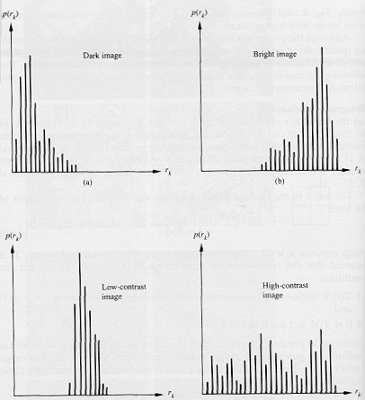

- Histogram equalization is a tranformation that stretches the contrast by redistribut-

ing the gray-level values uniformly.

- It is fully automatic compared to other contrast stretching techniques.

